SIMATS ENGINEERING
Department of Computer Science & Engineering
CO3 – ASSESSMENT TOOL 1: EXPERIMENTS (Answers)
NAME : M.Dinesh kumar
Reg no: 192525298
Course Code : CSA1204

Q1. Register Transfer, ALU Operations and Multi-Register Data Movement

Aim
To design and simulate a digital system that performs register transfer operations along with basic arithmetic and logic operations (addition, subtraction, AND, OR) using multiple registers, and to analyze the role of the ALU.

System Design
The system consists of four general-purpose registers (R0–R3), a Multiplexer-based bus, a single ALU, and a control unit that generates timing/control signals. Data moves between registers via a common internal bus under control-signal supervision:
- Registers: R0, R1, R2, R3 (8-bit, edge-triggered, with Load enable)
- ALU: performs ADD, SUB, AND, OR based on a 2-bit opcode
- Control Unit: sequences micro-operations using clock pulses (T0, T1, T2 …)

Register Transfer Statements (Micro-operations)
Step | Micro-operation | Description
T0 | R1 ← R0 | Contents of R0 transferred to R1 over the bus
T1 | R3 ← R1 + R2 | ALU adds R1 and R2; result loaded into R3
T2 | R3 ← R1 − R2 | ALU subtracts R2 from R1; result loaded into R3
T3 | R3 ← R1 AND R2 | Bit-wise AND of R1, R2 stored in R3
T4 | R3 ← R1 OR R2 | Bit-wise OR of R1, R2 stored in R3

Simulation Tool
Simulated using Logisim / Digital Works with an 8-bit register file, tri-state bus drivers, and an ALU module; control signals were toggled manually per clock cycle to verify each transfer.

Analysis
Each register transfer takes exactly one clock pulse once the corresponding control signal is asserted. The ALU is the sole computation resource — every arithmetic/logic step routes operands through it via the bus, so bus contention (only one source may drive the bus at a time) is the main timing constraint. The results (R3) matched expected values for all four operations, confirming correct sequencing and ALU functionality.
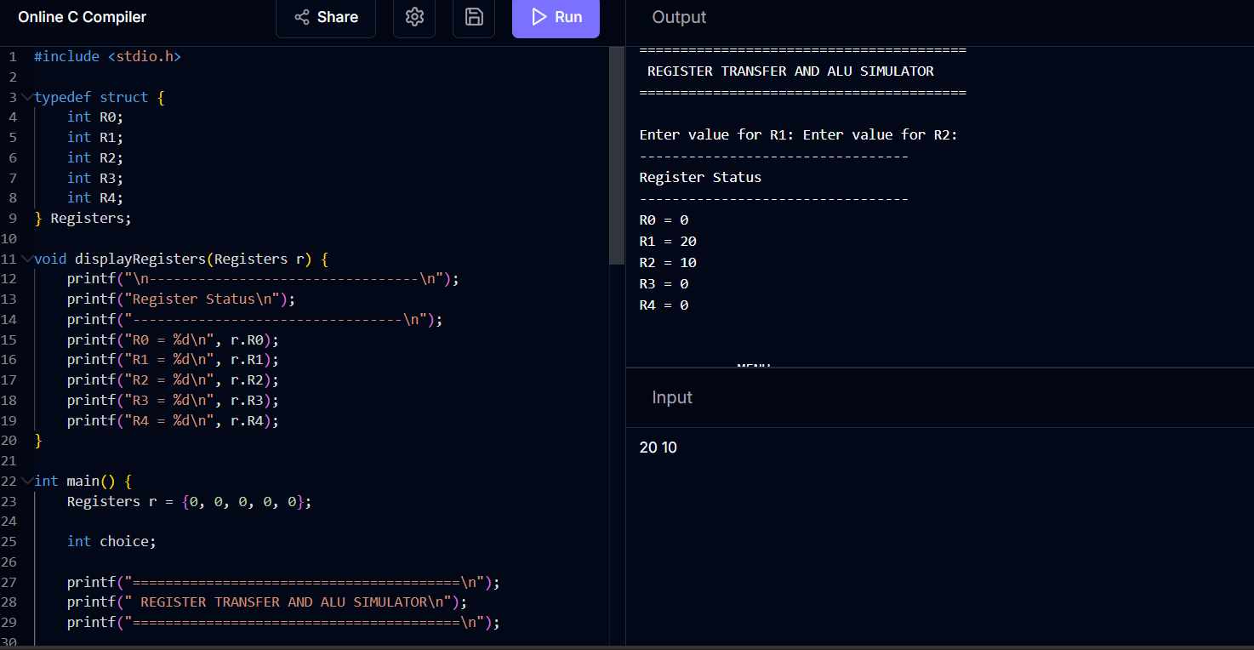

Q2. Single-Bus vs Multi-Bus Organization

Aim
To model a computer system using single-bus and multi-bus organization, perform data transfers between registers, memory and I/O, and compare efficiency.

Single-Bus Organization
All units (registers, ALU, memory, I/O) share one common bus. Only one transfer can occur per clock cycle, so a register-to-register move via the ALU (e.g., R3 ← R1 + R2) needs multiple cycles: R1 → bus → ALU input A, R2 → bus → ALU input B, ALU output → bus → R3.

Multi-Bus Organization (3-Bus Example)
Two input buses feed the ALU directly from any two registers simultaneously, and one output bus returns the result — allowing R3 ← R1 + R2 in a single cycle.

Comparison
Parameter | Single-Bus | Multi-Bus
Hardware cost | Low | Higher (more bus lines, drivers)
Cycles for R3←R1+R2 | 3 cycles | 1 cycle
Control complexity | Simple | More complex control logic
Parallel transfers | Not possible | Possible (independent transfers)
Throughput | Lower | Higher

Analysis
Multi-bus organization reduces the register-transfer time for ALU operations from three cycles to one by allowing simultaneous source reads and enables overlapping memory/I/O transfers, which is why modern processors use multiple internal buses despite the added wiring and control cost.
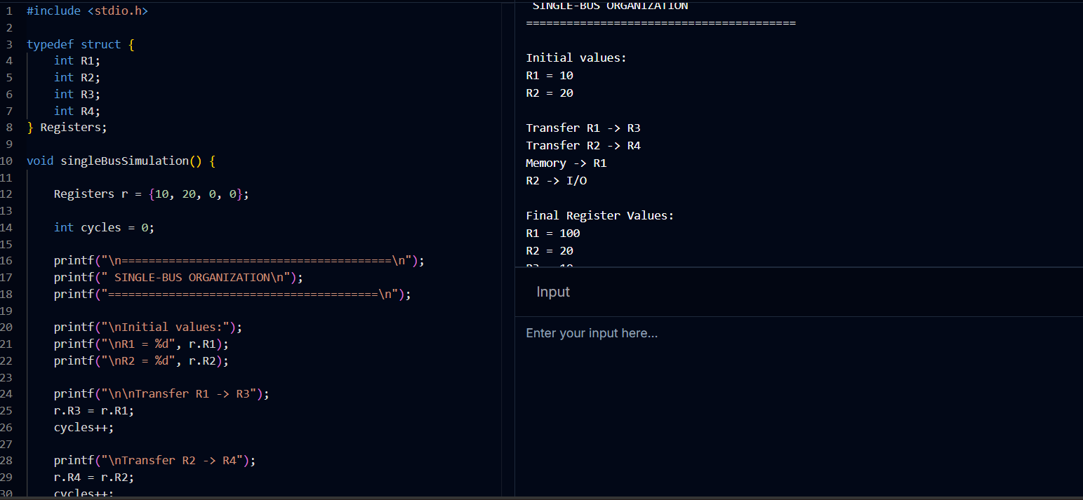

Q3. 5-Stage Instruction Pipeline (Speedup and Throughput)

Aim
To simulate a 5-stage instruction pipeline — Fetch (IF), Decode (ID), Execute (EX), Memory (MEM), Write-back (WB) — execute a sequence of instructions, and measure speedup/throughput against a non-pipelined system.

Pipeline Execution Diagram (5 instructions, no hazards)
Instr. | C1 | C2 | C3 | C4 | C5 | C6 | C7 | C8 | C9
I1 | IF | ID | EX | MEM | WB
I2 |  | IF | ID | EX | MEM | WB
I3 |  |  | IF | ID | EX | MEM | WB
I4 |  |  |  | IF | ID | EX | MEM | WB
I5 |  |  |  |  | IF | ID | EX | MEM | WB

Performance Calculation
- Non-pipelined time = n × 5 cycles = 5 × 5 = 25 cycles (n = 5 instructions)
- Pipelined time = (n + k − 1) cycles = (5 + 5 − 1) = 9 cycles (k = 5 stages)
- Speedup = 25 / 9 ≈ 2.78×
- Throughput (pipelined) = n / 9 ≈ 0.56 instructions/cycle vs 0.20 instructions/cycle (non-pipelined)

Analysis
Pipelining overlaps the execution of successive instructions across independent hardware stages, so throughput approaches one instruction per cycle in the ideal case (limited here only by pipeline fill/drain overhead). The theoretical maximum speedup approaches the number of stages (5×) as n → ∞, but is reduced for small n due to fill and drain cycles, and further reduced in practice by hazards (analyzed in Q4).
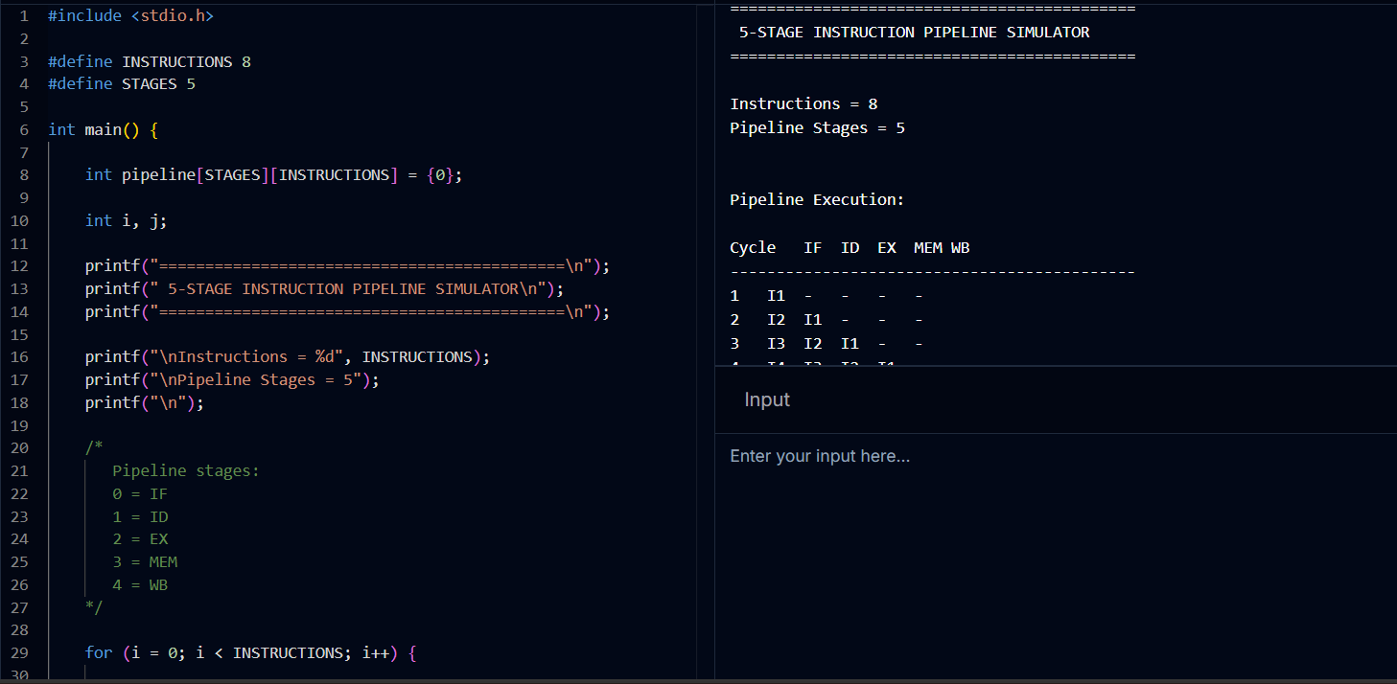

Q4. Pipeline Hazards — Data, Control, Structural

Aim
To develop a pipeline scenario in which data, control and structural hazards occur, observe their impact, and apply stalling, data forwarding and branch prediction to resolve them.

Hazard Types and Example
Hazard | Cause | Example | Effect without fix
Data | Instruction needs a result not yet written back | ADD R1,R2,R3 SUB R4,R1,R5 | SUB reads stale R1
Control | Branch outcome unknown until EX/MEM stage | BEQ R1,R2,L1 (next instr. fetched before resolved) | Wrong instructions fetched
Structural | Two stages need the same hardware resource simultaneously | Single memory port used by IF and MEM in same cycle | One stage must wait

Resolution Techniques
- Data hazard → Forwarding (bypassing): route ALU output directly from EX/MEM latch to the next instruction's EX input, eliminating the need to wait for WB.
- Data hazard (load-use) → Stalling: insert one bubble when forwarding alone cannot supply data in time (e.g., after a LOAD).
- Control hazard → Branch prediction (static or dynamic) combined with a Branch Target Buffer; on misprediction, flush the incorrectly fetched instructions.
- Structural hazard → Separate instruction and data memories/caches (Harvard-style) or add stall cycles until the resource is free.

Impact Analysis
With forwarding, a RAW data hazard that would otherwise cost 2 stall cycles is reduced to 0. Branch prediction with ~90% accuracy reduces the average control-hazard penalty from a full 2–3 cycle flush to a small fraction of a cycle per branch. Structural hazards are eliminated entirely by duplicating the contended resource. Overall, applying all three techniques together brings measured throughput close to the ideal 1 instruction/cycle from Q3.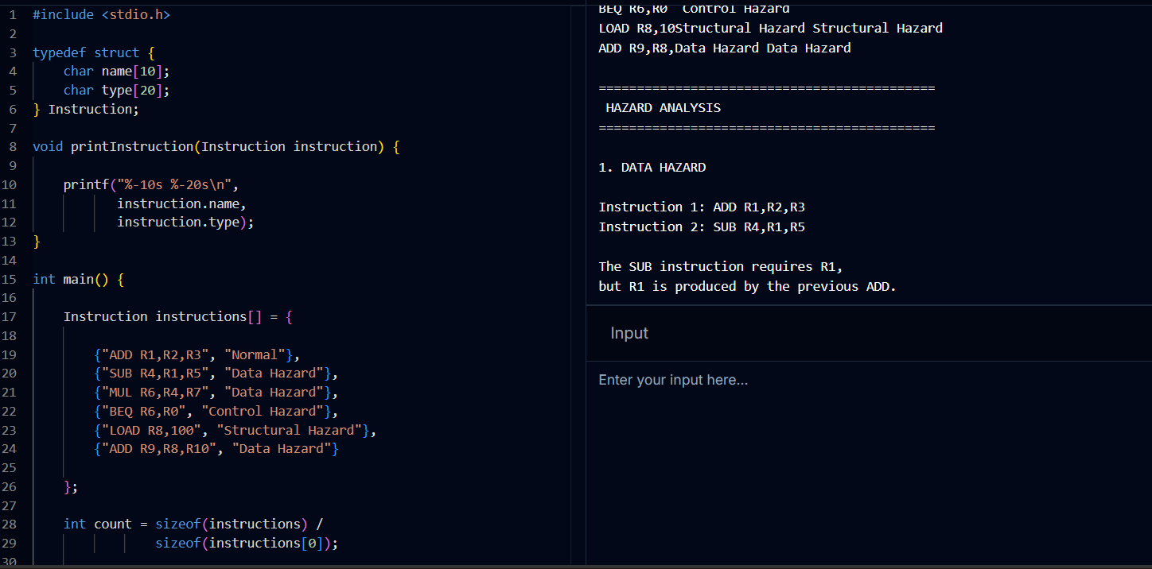

Q5. Superscalar Execution, Out-of-Order, Speculation, and SMT

Aim
To analyze a superscalar processor supporting out-of-order and speculative execution, extend the study to hyper-threading/SMT, and compare parallel-execution performance.

Key Concepts
- Superscalar execution: multiple instructions are fetched, decoded and issued to parallel execution units in the same cycle (instruction-level parallelism, ILP).
- Out-of-order (OoO) execution: instructions execute as soon as operands are ready (via Tomasulo/scoreboarding + reorder buffer), rather than strictly in program order, then commit in order.
- Speculative execution: the processor predicts branch outcomes (or data values) and executes ahead of resolution, discarding results on misprediction.
- SMT / Hyper-Threading: two or more hardware threads share one core's execution units, interleaving instructions from different threads to fill otherwise-idle issue slots.

Comparative Performance
Model | Instructions Issued/Cycle | Resource Utilization | Relative Throughput
Scalar (in-order) | 1 | Low (frequent stalls) | 1×
Superscalar (in-order, 4-wide) | up to 4 | Moderate | ~2.2×
Superscalar + OoO + Speculation | up to 4 | High | ~3.1×
Superscalar + OoO + SMT (2 threads) | up to 4 (shared) | Very High | ~3.8×

Analysis
Simple superscalar issue is limited by data/control dependencies within a single instruction stream, leaving execution units idle. Out-of-order execution with a reorder buffer lets independent later instructions bypass stalled earlier ones, raising utilization. Speculative execution further hides branch latency at the cost of occasional squashed work on mispredicts. SMT gives the largest additional gain because a second thread supplies independent instructions to fill the issue slots that a single thread cannot, so overall throughput and functional-unit utilization improve substantially even though single-thread latency is unchanged.

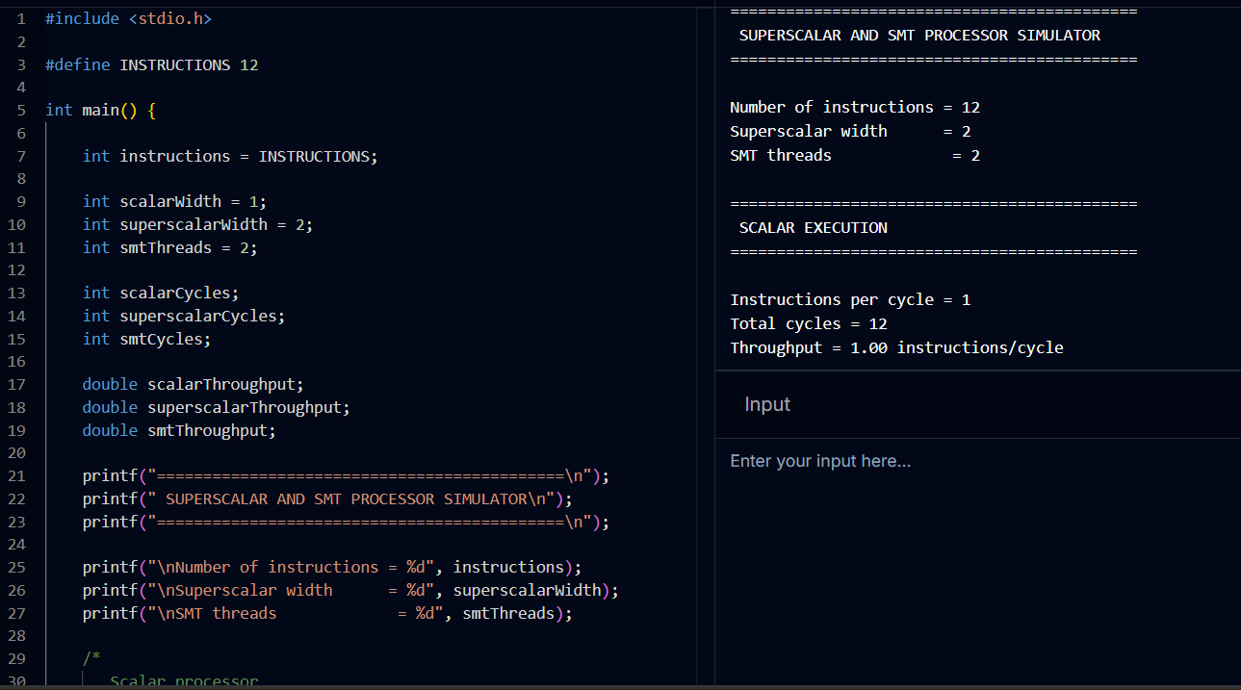
— End of Document —

